Testing Phase – 2

================================================================

1. We need a course to be displayed while we go to the course category, hover on should work.

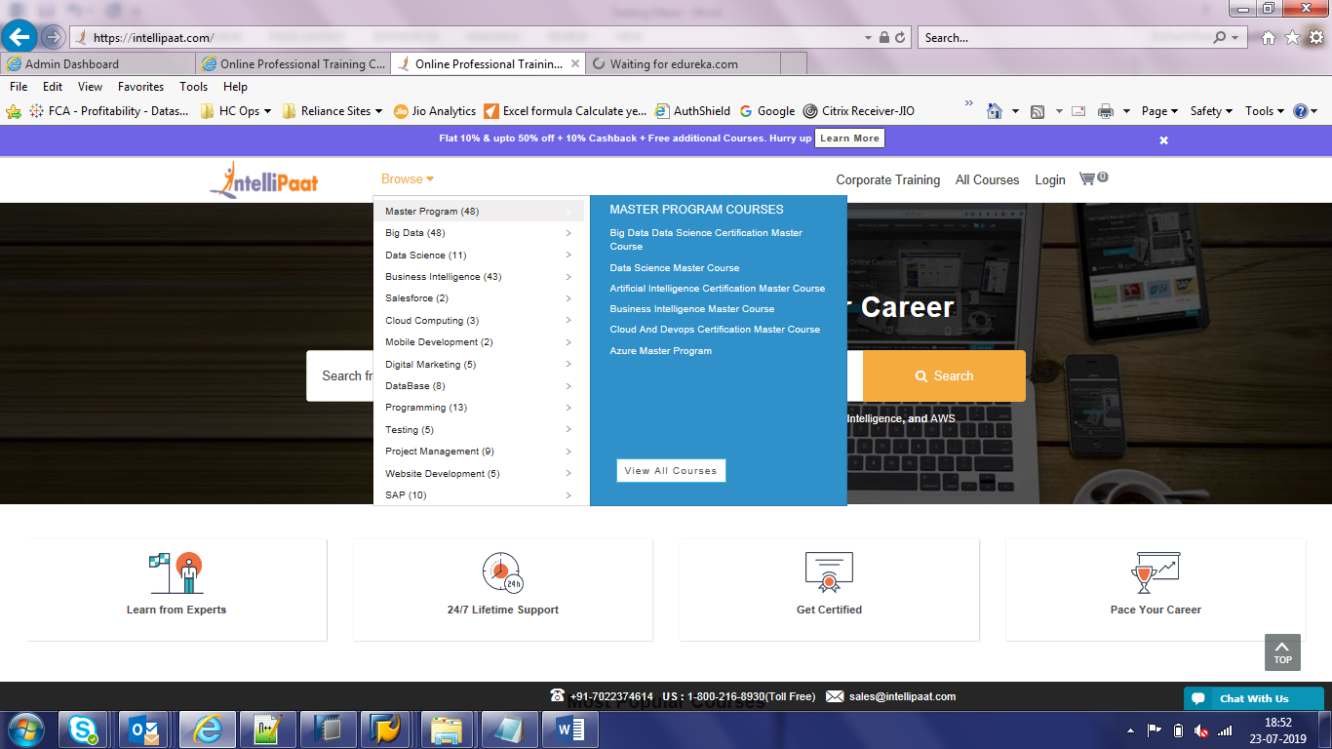

1. Reset Password should validate email id first and activation link to be sent to email id for validation.
2. Please provide a password hint help in the side of the text box , hovering on which it should show the validation.
3. Managing course seems difficult in admin panel , entire course materials for a topic should be allowed in one place , rather than adding one video or file at a time.
4. Offers to be shown at the top just like below clicking on which listed courses where offers are applicable with respective discount coupons to be shown , maintenance of which is also required in admin panel.



1. Blogs and other part to be embedded



1. Home Page image change to be allowed via admin panel
2. Course Category and courses should also come under the place Popular Courses from where the list can be seen in one page itself

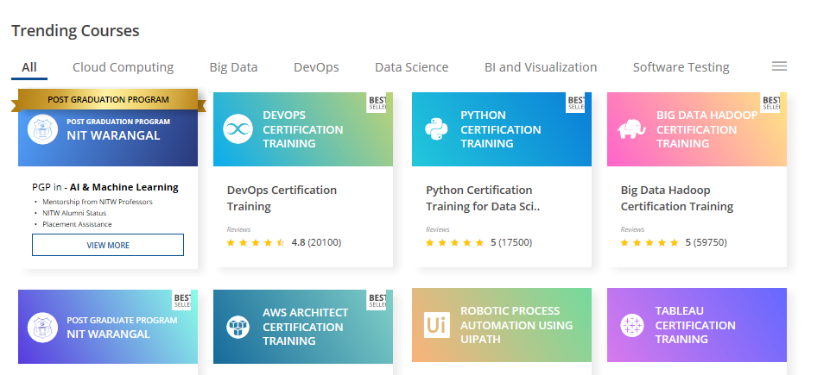

1. Same User is able to login into multiple devices at the same time.
2. Payment Details bank linking account details to be allowed to manage from admin panel for the payment done by users to my account(which can change from time to time)
3. Admin panel password change is not seen anywhere , this should also be allowed to maintain.
4. Reset Password shows otp(which is anyway not part of proposal as it is going to incur some charges) , instead a mail id should be validated and a link to reset should be sent for activation
5. Billing details should show the box representing in side not inside the box

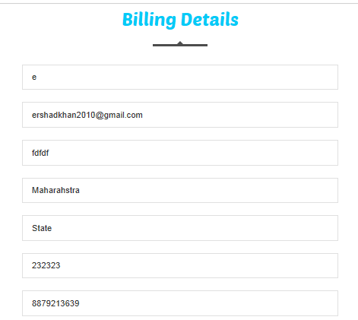

14.There should be one more amount allowed in admin tab for showing the actual amount which will be discounted and the final amount to be shown in the way it is shown below

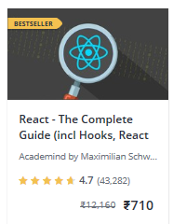

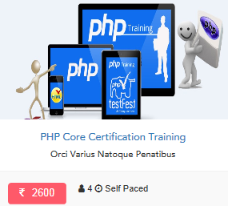

15.Live Chat bot is pending

16.Blog is pending

17.Unable to create additional pages in the end via manage page like testimonials etc.

18.Phone and Email id seems to be on different headings under manage Enquires

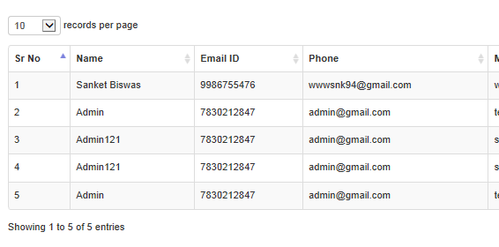

19.Manging Chats and replying them should be seen how it can be handled , it should allow multiple people from admin team or support team to reply.

20.Can’t see any usage in the dashboard even thogh multiple id’s are created.